General Information / Instruction

1. For clarifications, questions, or concerns feel free to contact me at kelly_flanagan@byu.edu or text or call 801-369-0033.
2. There are 5 “kits” for a total of 7 PCBs to assemble:
   1. **WiFiCPU** contains 1 PCB, more than enough of the necessary components, a stencil, a BOM, and the board layout.
   2. **Amplifier** contains 1 PCB, the necessary components other than those that can be found in other kits, a BOM, other documentation, and a stencil.
   3. **MP3** contains 1 PCB, all the necessary components other than those that can be found in the kit identified in the BOM. There is also a stencil for this board.
   4. **SPIMemory** contains 2 PCBs, and all necessary components. The required resistor can be found in the MP3 kit. The kit also contains the BOM and documentation.
   5. **3.3 Volt Power Supply** kit contains 2 PCBs, and all components other than those that can be found in the Amplifier and WiFiCPU kits. The BOM indicates where the missing components can be found.
3. 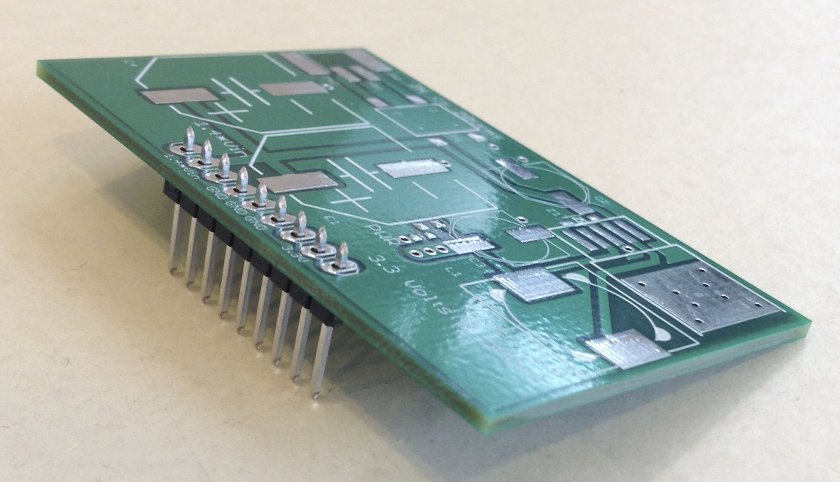In all boards the single row header pins are to be installed from the bottom / non-component side of each board so the boards can be installed in proto boards or through hole soldered to larger designs, see example below.